Concept_OCT_05_2016.png



**We will be using a Mindflex brain wave sensor to obtain the brain wave signals we need and input them into a microcontroller. We’ll then connect the microcontroller to the computer and decipher the signals generated from our thinking patterns, and with those we’ll set our threshold for standard value. In general, drone will fly based on your attention brainwave.**

**How It Works..**

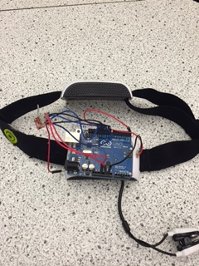

**Problem:**

**If you can’t work physically due to a disability, or even if you’re just a clumsy person**

**Mind control may be just for you.**

**Solution:**

**EEG Chip allows us to read raw signals from the brain and with those we can manipulate and apply them to commands and machinery to control them mentally.**

**EEG HEADSET ROBOT CONTROL**

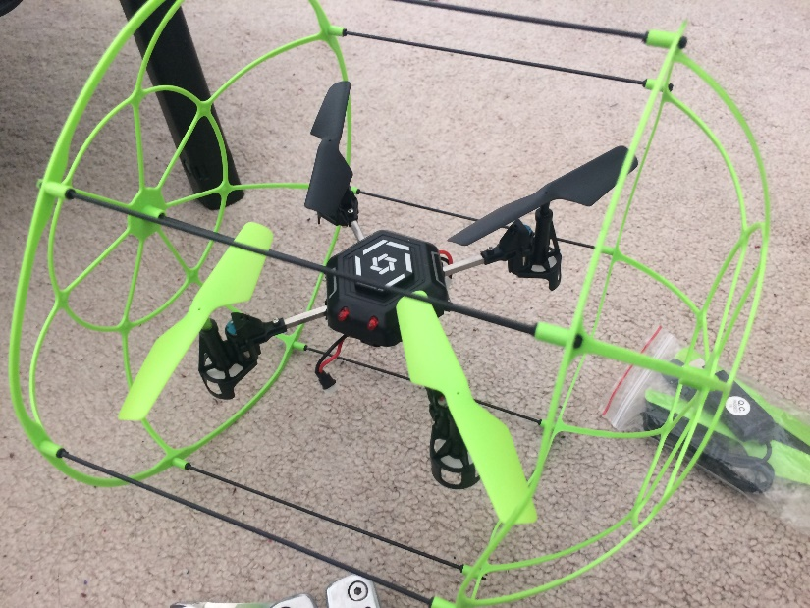

**To begin to mind control daily life objects with your mind,**

**You’ll have to start somewhere, so why not a simple drone. With the brain wave sensor signals, we will implement the signals into a drone to control it.**

**Controlling a Drone:**

**Mind Control:**